Experiment Details

|  |  |  |
| --- | --- | --- |
| Department Name | Basic Science and Humanities |  |
| Class | FY B.Tech |  |
| Semester | 1 st |  |
| Subject Name | Computer Programming Lab |  |
| Experiment No. | 01 |  |
| Experiment Name | * Verify truth table of Basic and Universal Gates * Derive different types of Gates by using NAND and NOR Gates |  |

Version History

|  |  |  |  |  |
| --- | --- | --- | --- | --- |
| Sr. No. | Version Number | Created By | Approved By | Date |
| 1 | v1.0 | Sonali Yeranale | MRS. Pooja Patil | 07/10/2020 |
|  |  |  |  |  |

AIM:

Logic Gates: Verify truth table of Basic and Universal Gates and Derive different types of Gates by using NAND and NOR Gates.

THEORY:

Logic gates are electronic circuits which perform logical functions on one or more inputs to produce one output. There are seven logic gates. When all the input combinations of a logic gate are written in a series and their corresponding outputs written along them, then this input/ output combination is called Truth Table.

NAND gate:-

[[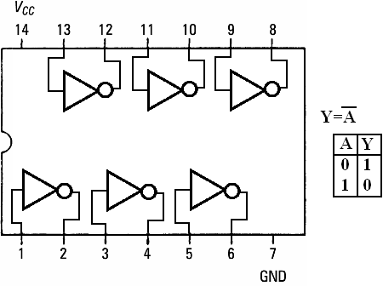](https://sites.google.com/site/amtmttl/st2/IC7404.PNG?attredirects=0)](https://sites.google.com/site/amtmttl/st2/IC7404.PNG?attredirects=0)

NAND gate is actually a series of AND gate with NOT gate. If we connect the output of an AND gate to the input of a NOT gate, this combination will work as NOT-AND or NAND gate. Its output is 1 when any or all inputs are 0, otherwise output is 1.

NOR gate:-

[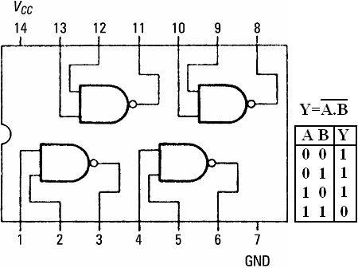](https://sites.google.com/site/amtmttl/st2/IC7400.png?attredirects=0)

NOR gate is actually a series of OR gate with NOT gate. If we connect the output of an OR gate to the input of a NOT gate, this combination will work as NOT-OR or NOR gate. Its output is 0 when any or all inputs are 1, otherwise output is 1.

Different types of gates using NAND gate:-

NAND gate is actually a combination of two logic gates: AND gate followed by NOT gate. So its output is complement of the output of an AND gate.

This gate can have minimum two inputs, output is always one. By using only NAND gates, we can realize all logic functions: AND, OR, NOT, X-OR, X-NOR, NOR. So this gate is also called universal gate.

A NOT produces complement of the input. It can have only one input, tie the inputs of a NAND gate together. Now it will work as a NOT gate. Its output is

Y = (A.A)’

                                           Y = (A)’

[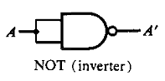](https://sites.google.com/site/amtmttl/st2/NAND%20AS%20NOT.PNG?attredirects=0)

A NAND produces complement of AND gate. So, if the output of a NAND gate is inverted, overall output will be that of an AND gate.

                                                Y = ((A.B)’)’

                                            Y = (A.B)

[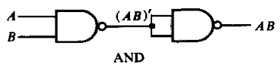](https://sites.google.com/site/amtmttl/st2/NAND%20AS%20AND.PNG?attredirects=0)

From DeMorgan’s theorems: (A.B)’ = A’ + B’

                                           (A’.B’)’ = A’’ + B’’ = A + B

So, give the inverted inputs to a NAND gate, obtain OR operation at output.

[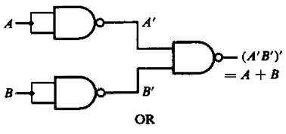](https://sites.google.com/site/amtmttl/st2/NAND%20AS%20OR.PNG?attredirects=0)

The output of a to input X-OR gate is shown by: Y = A’B + AB’. This can be achieved with the logic diagram shown in the left side.

[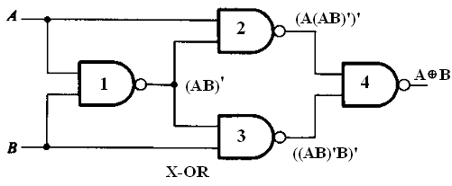](https://sites.google.com/site/amtmttl/st2/NAND%20AS%20XOR.PNG?attredirects=0)

X-NOR gate is actually X-OR gate followed by NOT gate. So give the output of X-OR gate to a NOT gate, overall ouput is  that of an X-NOR gate.

                                                Y = AB+ A’B’

[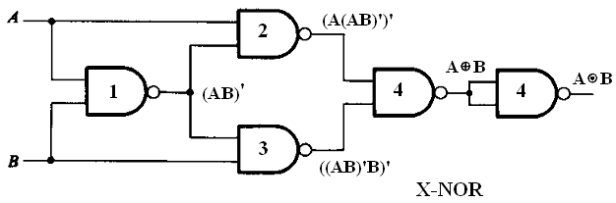](https://sites.google.com/site/amtmttl/st2/NAND%20AS%20XNOR.PNG?attredirects=0)

A NOR gate is an OR gate followed by NOT gate. So connect the output of OR gate to a NOT gate, overall output is that of a NOR gate.

                                                Y = (A + B)’

[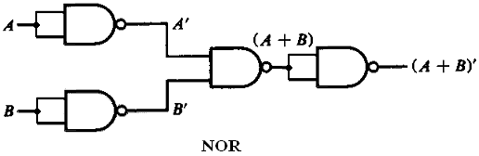](https://sites.google.com/site/amtmttl/st2/NAND%20AS%20NOR.PNG?attredirects=0)

Different types of gate using NOR:-

NOR gate is actually a combination of two logic gates: OR gate followed by NOT gate. So its output is complement of the output of an OR gate.

This gate can have minimum two inputs, output is always one. By using only NOR gates, we can realize all logic functions: AND, OR, NOT, X-OR, X-NOR, NAND. So this gate is also called universal gate.

A NOT produces complement of the input. It can have only one input, tie the inputs of a NOR gate together. Now it will work as a NOT gate. Its output is

Y = (A+A)’

                                        Y = (A)’

**[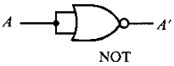](https://sites.google.com/site/amtmttl/st2/nor%20as%20not.PNG?attredirects=0)**

A NOR produces complement of OR gate. So, if the output of a NOR gate is inverted, overall output will be that of an OR gate.

                                                Y = ((A+B)’)’

                                         Y = (A+B)

[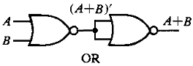](https://sites.google.com/site/amtmttl/st2/nor%20as%20or.PNG?attredirects=0)

From DeMorgan’s theorems: (A+B)’ = A’B’

                                            (A’+B’)’ = A’’B’’ = AB

So, give the inverted inputs to a NOR gate, obtain AND operation at output.

[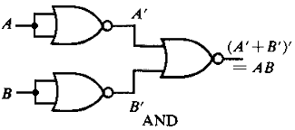](https://sites.google.com/site/amtmttl/st2/nor%20as%20and.PNG?attredirects=0)

The output of a two input X-NOR gate is shown by: Y = AB + A’B’. This can be achieved with the logic diagram shown in the left side.

[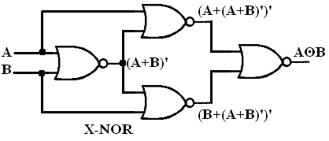](https://sites.google.com/site/amtmttl/st2/NOR%20AS%20XNOR.PNG?attredirects=0)

X-OR gate is actually X-NOR gate followed by NOT gate. So give the output of X-NOR gate to a NOT gate, overall output is that of an X-OR gate.

                                                Y = A’B+ AB’

[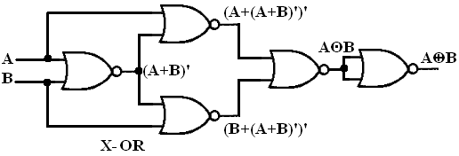](https://sites.google.com/site/amtmttl/st2/NOR%20AS%20XOR.PNG?attredirects=0)

A NAND gate is an AND gate followed by NOT gate. So connect the output of AND gate to a NOT gate, overall output is that of a NAND gate.

                                                Y = (AB)’

[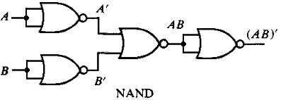](https://sites.google.com/site/amtmttl/st2/nor%20as%20nand.PNG?attredirects=0)

PRE TEST:

1. A universal logic gate is one which can be used to generate any logic function. Which of the following is a universal logic gate?

* OR
* AND
* XOR
* NAND

Answer: - NAND

1. Which of following are known as universal gates?

* NAND & NOR
* AND & OR
* XOR & OR
* EX-NOR & XOR

Answer: - NAND & NOR

1. Electronic circuits that operate on one or more input signals to produce standard output _______

* Series circuits
* Parallel Circuits
* Logic Signals
* Logic Gates

Answer: - Logic Gates

1. Logic Gates are the building blocks of all circuits in a computer.

* True
* False

Answer: - True

1. The gate which is called an inverter is called ________

* NOR
* NAND
* EXOR
* NOT

Answer: - NOT

PROCEDURE:-

Procedure for truth table of Basic and Universal Gates :-

1. Connect the trainer kit to ac power supply.
2. Connect the inputs of any one logic gate to the logic sources and its output to the logic indicator.
3. Apply various input combinations and observe output for each one.
4. Verify the truth table for each input/ output combination.
5. Repeat the process for all other logic gates.
6. Switch off the ac power supply.

Procedure of different types of gates using NAND:-

1. Connect the trainer kit to ac power supply.
2. Connect the NAND gates for any of the logic functions to be realised.
3. Connect the inputs of first stage to logic sources and output of the last gate to logic indicator.
4. Apply various input combinations and observe output for each one.
5. Verify the truth table for each input/ output combination.
6. Repeat the process for all logic functions.
7. Switch off the ac power supply.

Procedure of different types of gates using NOR:-

1. Connect the trainer kit to ac power supply.
2. Connect the NOR gates for any of the logic functions to be realised.
3. Connect the inputs of first stage to logic sources and output of the last gate to logic indicator.
4. Apply various input combinations and observe output for each one.
5. Verify the truth table for each input/ output combination.
6. Repeat the process for all logic functions.
7. Switch off the ac power supply.

POST TEST:

1. The NOR gate is OR gate followed by ………………

* AND gate
* NAND gate
* NOT gate
* None of the above

Answer: -NOT gate

1. When an input signal 1 is applied to a NOT gate, the output is ………………

* 0
* 1
* Either 0 & 1
* None of the above

Answer: - 0

1. How many AND gates are required to realize the following expression Y=AB+BC?

* 4
* 8
* 1
* 2

Answer:-2

1. The universal gate that can be used to implement any Boolean expression is __________

* NAND
* EXOR
* OR
* AND

Answer: - NAND

REFERENCES:

Computer programming Lab from Let Us C by Yashwant Kanetkar.